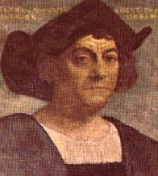
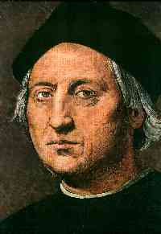
Chandelar R. 8-1
10-12-06

Christopher Columbus
He was born in 1451 at Genoa, Italy. He was the oldest child out of 5. As a child he helped his father as a weaver. And always liked the sea. Then he died May 20, 1506. In 1492 he sailed from Spain across the Atlantic Ocean, landing in the “New World”. Columbus sailed west in search of a sea passage to India. He was best known as the explorer who opened the door to the Americas.

The websites I went to, to find these are….
http://www.who2.com/ask/christophercolumbus.html and http://www.ask.com/web?q=pictures+of+Christopher+Columbus&qsrc=0&o=333&l=dir.html

